|  |
| --- |
| Day 8 assignments by Lokesh nadella |

1.declare and initialize a list with 8 values and write for loop,foreach loop,lambda,linq query to print even numbers??

using System;

using System.Collections.Generic;

using System.Linq;

using System.Text;

using System.Threading.Tasks;

namespace day8_project

{

internal class Program

{

static void Main(string[] args)

{

List<int> data = new List<int>() { 1, 2, 3, 4, 5, 6, 7, 8 };

// using for loop

for (int i = 0; i < data.Count; i++)

{

if (data[i] % 2 == 0)

Console.WriteLine(data[i]);

}

// using forach loop

foreach (var d in data)

{

if (d % 2 == 0)

Console.WriteLine(d);

}

// using lamda expression

data.Where(d => d % 2 == 0).ToList().ForEach(d => Console.WriteLine(d));

// using LINQ Query

var result = from d in data

where d % 2 == 0

select d;

result.ToList().ForEach(d => Console.WriteLine(d));

Console.ReadLine();

}

}

}

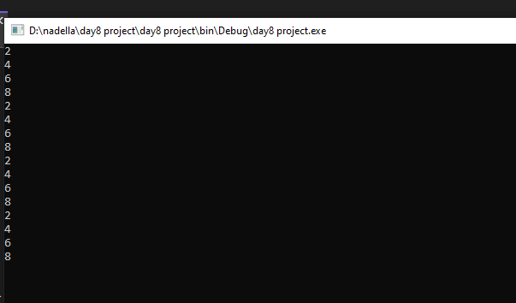

2.create a class employee with 3 variables as discussed in class and create a list of employess?

using System;

using System.Collections.Generic;

using System.Linq;

using System.Text;

using System.Threading.Tasks;

//****************

//AUTHOR:lokesh nadella

//purpose:print employee id ,salary,name

//****************

namespace day8_assignments

{

class Employee

{

public int Id;

public string Name;

public int salary;

}

internal class Program

{

static void Main(string[] args)

{

List<Employee> employees = new List<Employee>()

{

new Employee() { Id = 101, Name = "lokesh", salary = 15000 },

new Employee() { Id = 102, Name = "sanjay", salary = 10000 },

new Employee() { Id = 103, Name = "siva", salary = 20000 },

new Employee() { Id = 104, Name = "pavan", salary = 30000 },

new Employee() { Id = 105, Name = "chandra", salary = 40000 },

};

// create employees using FOR LOOP

for (int i = 0; i < employees.Count; i++)

{

Console.WriteLine($"id={employees[i].Id},name={employees[i].Name}, salary={employees[i].salary}");

}

Console.WriteLine("*******");

// create employeees using FOREACH LOOP

foreach (var e in employees)

{

Console.WriteLine($"id ={e.Id}, name={e.Name}, salary={e.salary}");

}

Console.WriteLine("********");

// create employees using LAMBDA EXPRESSION

employees.ToList().ForEach(e => Console.WriteLine($"id{e.Id}, name={e.Name}, salary={e.salary}"));

Console.WriteLine("*******");

// create employees using LINQ QUERY

var result = from e in employees

select e;

result.ToList().ForEach(e => Console.WriteLine($"id{e.Id},name={e.Name},salary={e.salary}"));

Console.ReadLine();

}

}

}

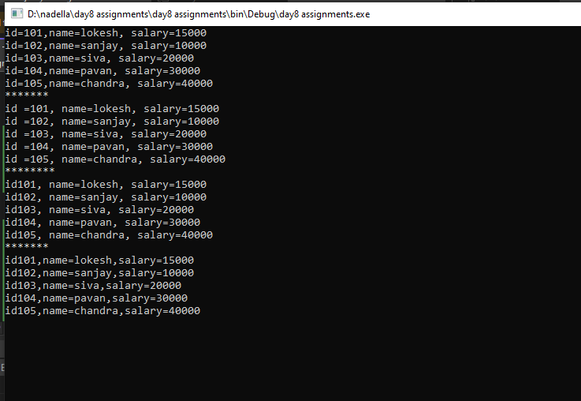

3.create a class product and add variables id,name,price and brand and print product(name,brand)whose price is more than 500??

using System;

using System.Collections.Generic;

using System.Linq;

using System.Text;

using System.Threading.Tasks;

namespace day8_assignmnt

{

class Product

{

public int Id;

public string Name;

public int Price;

public string Brand;

}

internal class Program

{

static void Main(string[] args)

{

Product[] product = new Product[]

{

new Product() { Id = 100, Name ="shoe", Price =30, Brand="adidas"},

new Product() { Id = 101, Name ="clothes",Price=1000, Brand="nike"},

new Product() { Id = 103, Name ="shirts",Price=100, Brand="raymond"},

new Product() { Id = 105, Name ="pen",Price=10, Brand="Cello"},

new Product() { Id = 107, Name ="watch",Price=2000, Brand="Fastrack"}

};

//price is >500 using FORLOOP

for (int i = 0; i < product.Length; i++)

{

if (product[i].Price >= 500)

Console.WriteLine($"name={product[i].Name},Brand={product[i].Brand}");

}

//price is >500 using FOREACH LOOP

foreach (var e in product)

{

if (e.Price >= 500)

Console.WriteLine($"Name={e.Name},Brand{e.Brand}");

}

//price is >500 using LAMBDA EXPRESSION

product.ToList().Where(e => e.Price >= 500).ToList().ForEach(e => Console.WriteLine($"Name={e.Name},Brand={e.Brand}"));

//price is >500 using LINQ QUERY

var result = from e in product

where e.Price >= 500

select e;

result.ToList().ForEach(e => Console.WriteLine($"Name={e.Name}, Brand={e.Brand}"));

Console.ReadLine();

}

}

}

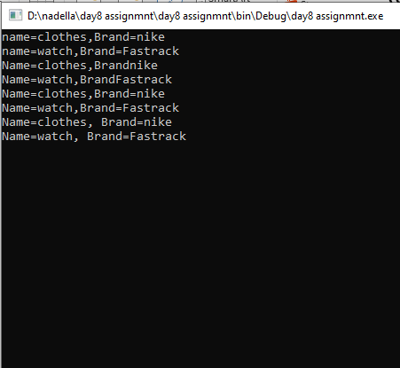

4.creata a department class and add variables id ,name,,empcount and write a code to print id,name of department whose empcount is greater than 50??

using System;

using System.Collections.Generic;

using System.Linq;

using System.Text;

using System.Threading.Tasks;

namespace day8_asignment

{

class Department

{

public int id;

public string name;

public int empcount;

}

internal class Program

{

static void Main(string[] args)

{

Department[] department = new Department[]

{

new Department(){ id = 1, name ="developer",empcount=51},

new Department(){ id = 2, name ="back end",empcount =30},

new Department(){ id = 3, name ="testing", empcount =100},

new Department(){ id = 4, name ="sql developer", empcount=29},

new Department(){ id = 5, name ="front end",empcount=(63)}

};

//empcount >50 using FORLOOP

for (int i = 0; i < department.Length; i++)

{

if (department[i].empcount > 50)

Console.WriteLine($"id={department[i].id},name={department[i].name}");

}

// empcount >50 using FOREACH LOOP

foreach (var e in department)

{

if (e.empcount > 50)

Console.WriteLine($"id={e.id},name={e.name}");

}

// empcount >50 using LAMBDA EXPRESSION

department.ToList().Where(e => e.empcount > 50).ToList().ForEach(e => Console.WriteLine($"id={e.id},name={e.name}"));

// empcount >50 using LINQ query

var result = from e in department

where e.empcount > 50

select e;

result.ToList().ForEach(e => Console.WriteLine($"id={e.id},name={e.name}"));

Console.ReadLine();

}

}

}

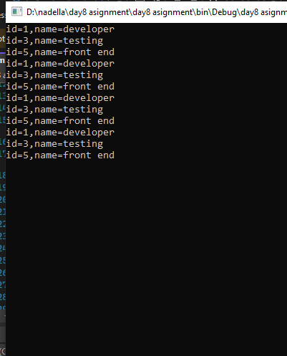

5.create a a own class and variables and initialize with some values

1.for loop

2.foreach loop

3.lambda

4.linq query

using System;

using System.Collections.Generic;

using System.Linq;

using System.Text;

using System.Threading.Tasks;

namespace DAY8_ASSIGNMNTS

{

class food

{

public int price;

public string name;

public int quantity;

internal class ToList { }

}

internal class Program

{

private static void Main(string[] args)

{

List<food> food = new List<food>()

{

new food() { name = "french fries", price = 50, quantity = 2 },

new food() { name = "burger", price = 100, quantity = 3 },

new food() { name = "chicken burger", price = 50, quantity = 6 },

new food() { name = "pizza", price = 100, quantity = 2 },

};

// using FORLOOP

for (int p = 0; food.Count > 0; p++)

{

if (food.Count > 1)

Console.WriteLine($"p={food[p]},name={food[p].name}");

};

// using FOREACH LOOP

foreach (var p in food)

{

if (food.Count > 1)

Console.WriteLine($"quantity={p.quantity},name={p.name}");

}

// using LAMBDA EXPRESSION

food.ToList().ForEach(p => Console.WriteLine($"quantity={p.quantity},name={p.name}"));

// create employees using LINQ QUERY

var result = from p in food

select p;

result.ToList().ForEach(p => Console.WriteLine($"quantity={p.quantity},name={p.name}"));

Console.ReadLine();

}

}

}

